Muhammad Tanzil-ur-Rehman

BCS211037

Section 1

**Task 01**

.model small

.data

.code

mov cl,26

mov dl,65

l1:

mov ah,02

int 21h

inc dl

loop l1

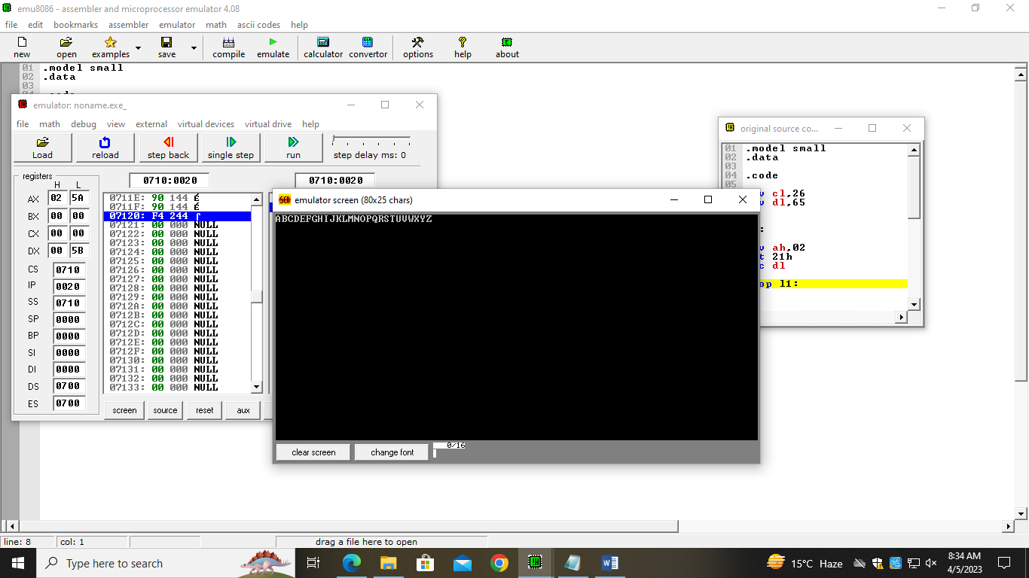

**Task 02**

.model small

.data

.code

mov cl,26

mov dl,97

l1:

mov ah,02

int 21h

inc dl

loop l1:

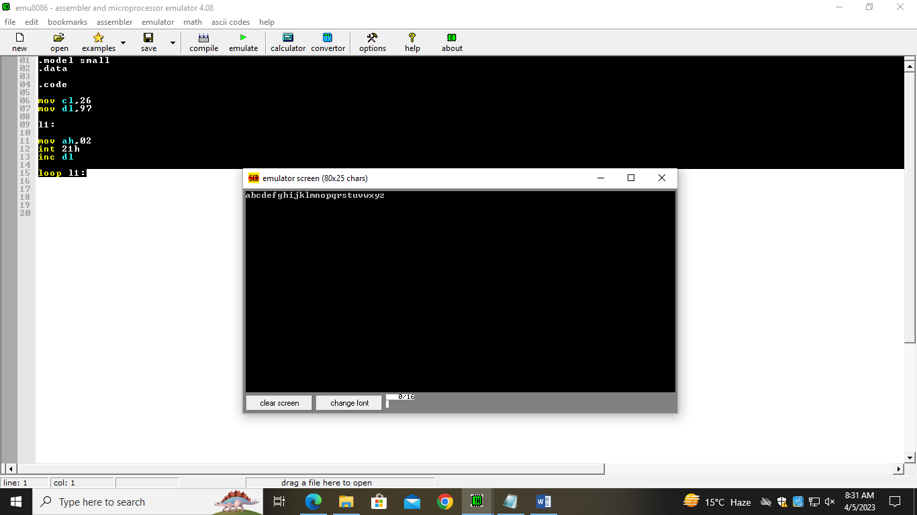

**Task 03**

.model small

.data

max db ?

num1 db ?

msg1 db ,0ah,0dh,"Enter the number ", ": $"

msg2 db ,0ah,0dh,"The Greatest Number is"," : $"

.code

mov ax,@data

mov ds,ax

;printing string

lea dx,msg1

mov ah,9

int 21h

mov cl,9

mov dl,0

mov ah,01

int 21h

;moving first value in max variable

mov max,al

;loop is start to be runnig

l1:

mov ah,2

mov dl,0dh

int 21h

mov dl,0ah

int 21h

mov ah,1

int 21h

mov num1,al

mov bl,max

;comparing the two values

cmp al,bl

;jump statement is used

JG a1

jmp a2

a1:

mov max,al

a2:

loop l1

;loop is ending

lea dx,msg2

mov ah,9

int 21h

mov dl,max

mov ah,2

int 21h

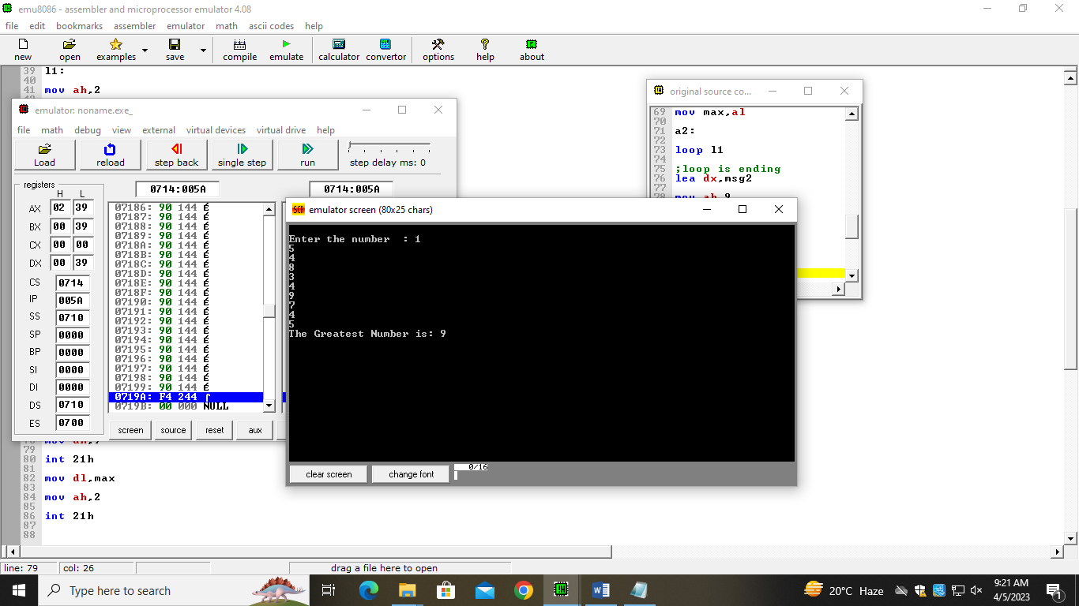

**Task 04**

.model small

.data

.code

mov cl,10

mov dl,57

l1:

mov ah,02

int 21h

dec dl

loop l1:

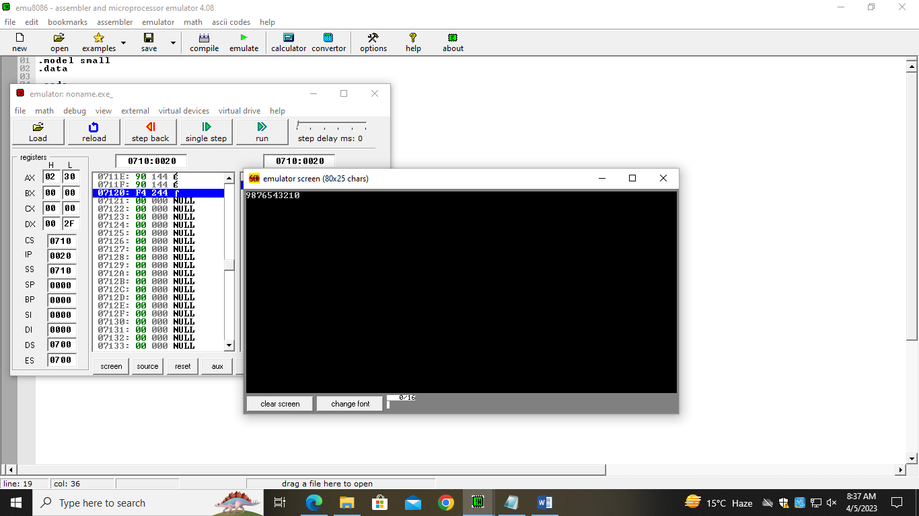

**Task 05**

.model small

.data

msg db "The odd number are ","$"

.code

mov ax,@data

mov ds,ax

mov cl,5

mov bh,11

lea dx,msg

mov ah,09

int 21h

l1:

sub bh,2

mov dl,bh

;convert into decimal from ascii codes

add dl,48

mov ah,02

int 21h

loop l1

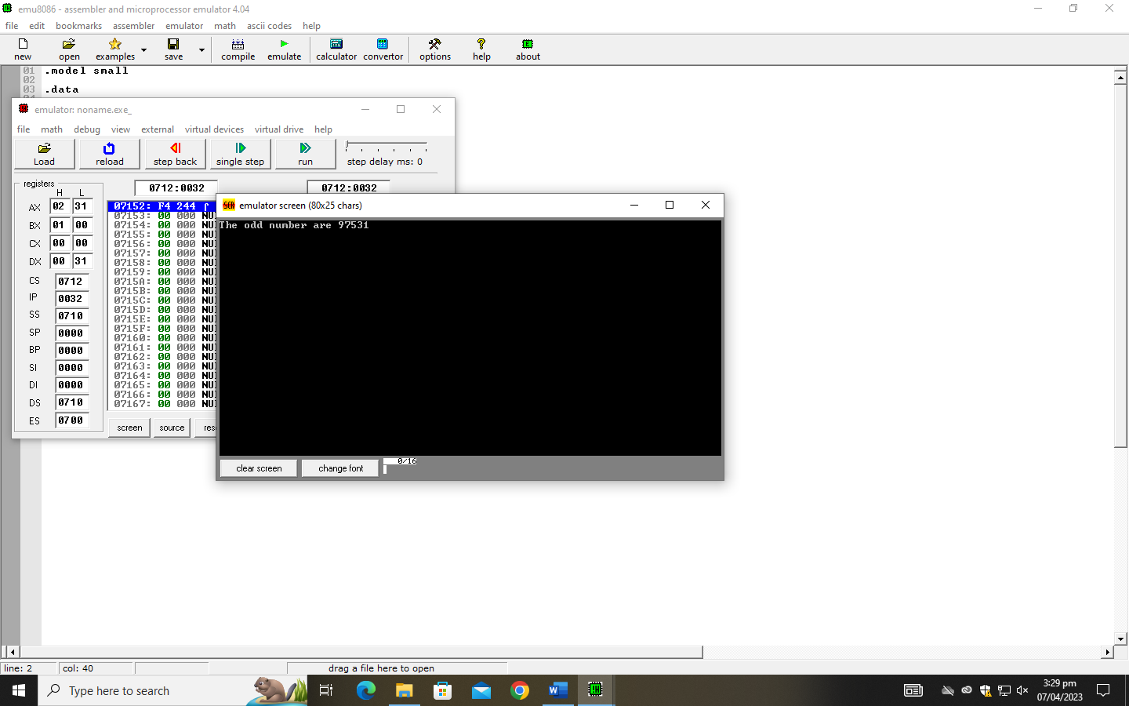

**Task 06**

.model small

.data

msg db "The even number are ","$"

.code

mov ax,@data

mov ds,ax

mov cl,5

mov bh,10

lea dx,msg

mov ah,09

int 21h

l1:

sub bh,2

mov dl,bh

;convert into decimal from ascii codes

add dl,48

mov ah,02

int 21h

loop l1

